

SCHOOL OF ELECTRONICS AND COMMUNICATION ENGINEERING

A MINI PROJECT REPORT
ON
“Biometric Polling System”
Submitted in fulfillment of the requirements for the award of the Degree of

BACHELOR OF TECHNOLOGY
IN
ELECTRONICS AND COMMUNICATION ENGINEERING

Submitted by

Eshan Karthik (R23EN049)
Aryan Sharma (R23EN024)
Harshitha J (R23EN057)
Neeral Devni (R23EN204)

Under the guidance of
Dr. K.M. Sudharshan & Dr. Ravishankar D
School of ECE, REVA University

Rukmini Knowledge Park, Kattigenahalli, Yelahanka, Bengaluru-560064
www.reva.edu.in

DECLARATION

We, Eshan Karthik (R23EN049), Aryan Sharma (R23EN024), Harshitha J (R23EN057) , Neeral Devni (R23EN204) students of B. Tech (ECE) belonging to the School of Electronics and Communication Engineering, REVA University, declare that this Mini Project Report titled “Biometric Polling System” is the result of the Mini Project Work done by us under the supervision of Dr. K.M.Sudharshan & Dr. Ravishankar, School of ECE REVA University.

We are submitting this Mini Project Report in partial fulfillment of the requirements for the award of the degree of Bachelor of Technology in Electronics and Communication Engineering by the REVA University, Bengaluru during the academic year 2026-27.

We declare that this project report satisfies the academic requirements concerning the Mini Project work prescribed for the said Degree. We further declare that this Mini Project or any part of it has not been submitted for the award of any other Degree/Diploma of this University or any other University/ Institution.

Signature of the Students
Date:

Certified that this Mini Project work submitted by, Eshan Karthik (R23EN049), Aryan Sharma (R23EN024), Harshitha J (R23EN057) , Neeral Devni (R23EN204) has been carried out under my guidance and the declaration made by the candidates is true to the best of my knowledge.

Signature of Guide
Date:



SCHOOL OF ELECTRONICS AND COMMUNICATION ENGINEERING

CERTIFICATE

Certified that the Mini Project work titled “Biometric Polling System” carried out under the guidance of the undersigned by Eshan Karthik (R23EN049), Aryan Sharma (R23EN024), Harshitha J(R23EN057), Neeral Devni (R23EN204) bonafide students of REVA University during the academic year 2026-27, is submitting the Mini project report in partial fulfillment for the award of Bachelor of Technology in Electronics and Communication Engineering during the academic year 2026-27. The project report has been approved as it satisfies the academic requirements with respect of the Project work prescribed for the said Degree.

Signature with Date |  | Signature with Date
Dr. Ravishankar D |  | Dr. K.M.Sudharshan
Guide |  | Director, School of ECE

 | Name of the Examiner with affiliation |  | Signature with Date
1.
2.

ACKNOWLEDGEMENTS

This satisfaction and euphoria that accompany the successful completion of any task would be incomplete without the mention of the people who made it possible with constant guidance and encouragement and crowned our efforts with success.
A hearty thanks to Guides, Dr. K.M.Sudharshan & Dr. Ravishankar, School of ECE, for their guidance and support throughout the course.
Thanks to Microcontroller Theory & Lab Faculties, and Coordinators for constant encouragement and support.
We are grateful to Dr. K. M Sudharshan, Director, School of Electronics & Communication Engineering, REVA University, Bangalore, for their valuable support and encouragement.
We also thank all the School of Electronics and Communication Engineering Staff Members and those who have directly or indirectly helped us with their valuable suggestions in completing this project.
We thank Dr. R. C. Biradar, Pro-Vice Chancellor, and Dr. Sanjay Chitnis, Vice Chancellor, REVA University, Bangalore, for extending their support.

We also thank our Honourable Chancellor, Dr. P Shyamaraju, for his support, encouragement, and excellent infrastructure/resources.
Lastly, we thank our beloved Parents & Siblings for their blessings, love, and encouragement to complete the task by meeting all the requirements.

Abstract
This project presents the design and implementation of a Biometric Polling System using an ESP32 microcontroller, R307 fingerprint sensor, webcam-based voter verification, and an offline database system. The system is developed to improve election transparency and prevent duplicate voting, impersonation, and unauthorized access using fingerprint-based voter identification.
The ESP32 controls fingerprint verification, voter registration, LCD display operation, and communication with the Python backend system. A 16×2 I2C LCD provides voting instructions, while push buttons are used for candidate selection. A webcam captures voter images for additional verification and monitoring. The backend stores voter details, fingerprint IDs, images, and vote counts using an offline CSV-based database system.
The implemented system achieved a fingerprint matching accuracy of 95–98% with an average verification time of 1–2 seconds. Voter registration was completed in less than 1 second, and duplicate voting detection achieved 100% success during testing. A dynamic OTP-like administrator access mechanism was also implemented for protected result access.
The project demonstrates that biometric authentication combined with offline database management provides a reliable, low-cost, and efficient electronic voting solution suitable for college elections, organizational polling, and secure booth-based voting applications.

Table Of Contents
CHAPTER | TITLE | PAGE
 | ABSTRACT
1. | INTRODUCTION | 1
2. | LITERATURE SURVEY | 4
3. | PROPOSED WORK | 6
4. | HARDWARE DESCRIPTION | 10
5. | SOFTWARE DESCRIPTION | 18
6. | IMPLEMENTATION | 22
7. | RESULT AND DISCUSSION | 30
8. | CONCLUSION AND FUTURE SCOPE | 32
9. | REFERENCES | 33

Chapter 1
INTRODUCTION
Elections are one of the most important processes in any democratic system, as they allow citizens to choose their representatives and leaders. Traditional voting systems based on paper ballots often face issues such as impersonation, ballot tampering, manual counting errors, and long result processing times. Although Electronic Voting Machines (EVMs) have improved the efficiency of elections, many existing systems still lack reliable voter verification and proper vote management mechanisms. To overcome these limitations, biometric-based electronic voting systems have gained significant importance in recent years.
Biometric identification refers to the process of recognizing an individual using unique physical characteristics such as fingerprints, facial patterns, iris scans, or voice recognition. Among these techniques, fingerprint recognition is widely preferred because fingerprints are unique for every individual, easy to capture, dependable, and economical. Fingerprint-based voting systems help reduce fake voting attempts and impersonation while improving transparency and reliability in elections.
This project focuses on the design and implementation of a Biometric Polling System using an ESP32 Dev Board, R307 fingerprint sensor, webcam-based image verification, 16×2 LCD display, push-button voting interface, and an offline Python-based database system. The system is designed to simulate a real-world electronic voting machine capable of verifying voters through fingerprints and storing vote data efficiently without depending on internet connectivity.
The ESP32 microcontroller acts as the central processing unit of the system. It manages fingerprint verification, LCD display operations, buzzer feedback, push-button voter registration, and communication with the Python backend through serial communication. The R307 fingerprint sensor is used to enrol and verify fingerprints of registered voters. During the voting process, the voter places a finger on the sensor, and the fingerprint is compared with stored templates for identification. If the fingerprint matches a registered voter, access to voting is granted.
A 16×2 I2C LCD display is used to provide instructions and status messages such as “Place Finger,” “Verified,” “Vote Recorded,” and “Already Voted.” Four push buttons connected to the ESP32 represent different candidates or voting options. After successful verification, the voter can cast a vote using the desired button. Once a vote is registered, the voter is marked as “Already Voted” in the database to prevent multiple voting attempts.
A USB webcam connected to the laptop captures voter images during registration and verification. The captured images are stored in an offline database system developed using Python. The backend database maintains voter details, fingerprint IDs, stored images, and vote counts using CSV files and local storage. Since the system operates completely offline, it avoids cybersecurity risks associated with cloud-based voting systems and internet connectivity.
One of the unique features of the proposed system is the implementation of a rotating OTP-like encryption mechanism for result access. The ESP32 continuously generates a dynamic security code that changes every 15 seconds. Only authorized users with the correct code can access the final vote count, providing an additional layer of protection against unauthorized access.
The proposed biometric polling system offers several advantages such as improved election reliability, prevention of fake voting, offline operation, real-time voter verification, low-cost implementation, and easy scalability. The project demonstrates the integration of embedded systems, biometric identification, computer vision, serial communication, and offline database management into a single electronic voting platform.
The system can be effectively used for college elections, employee voting systems, local body elections, organizational polling, and booth-based voting applications. Future enhancements such as cloud synchronization, face recognition, blockchain-based vote storage, and touchscreen interfaces can further improve the system’s performance and usability.
Overall, the project provides a practical and reliable solution for electronic voting using biometric identification and offline database management.
1.1 Problem Statement
Traditional voting systems are prone to issues such as fake voting, voter impersonation, ballot tampering, and delays in vote counting. Existing electronic voting systems may improve efficiency but often lack reliable voter verification and proper protection against unauthorized access. Additionally, online voting systems are vulnerable to cybersecurity threats and internet-based attacks. Therefore, there is a need for a reliable, low-cost, and offline biometric voting system that can accurately verify voters, prevent multiple voting attempts, and securely manage election data.
1.2 Objectives
- To design and develop a biometric polling system using the ESP32 microcontroller and R307 fingerprint sensor.
- To implement fingerprint-based voter identification for accurate voter verification.
- To provide a push-button interface for easy vote casting.
- To develop an offline Python-based database for storing voter information and vote counts.
- To prevent multiple voting attempts by maintaining voter status records.
- To integrate webcam-based image capture for additional voter verification.
- To implement a rotating OTP-based mechanism for protected result access.
- To create a low-cost, reliable, and scalable electronic voting solution suitable for small-scale election applications.

Chapter 2
LITERATURE SURVEY
Sl.no. | Paper name with author(s) | Key takeaway
1. | S. A. Karthik, R. Praveen, and M. Vignesh, “Fingerprint Based Electronic Voting Machine Using Microcontroller,” International Journal of Engineering Research & Technology (IJERT), 2020. | Demonstrates fingerprint-based voter authentication for preventing duplicate voting and improving election security using microcontroller-based implementation.
2. | A. Kumar and S. Singh, “Biometric Authentication System for Secure Electronic Voting,” International Journal of Computer Applications, 2020. | Presents biometric authentication methods for improving voter verification accuracy and reducing unauthorized voting attempts.
3. | M. K. Hasan, M. M. Rahman, and S. Islam, “Design and Implementation of Fingerprint Based Voting System,” IEEE International Conference on Electrical, Computer and Communication Engineering (ECCE), 2019. | Proposes fingerprint-based electronic voting with improved transparency, reliable authentication, and secure vote management.
4. | R. Ramya and P. Deepalakshmi, “Secure Smart Voting System Using Biometrics,” International Journal of Advanced Research in Computer and Communication Engineering, 2019. | Introduces biometric verification techniques to reduce fake voting and improve election reliability through secure voter identification.
5. | Abhay L. Holkar and Pooja R. Marab, “IoT-Based Real-Time Security and Malfunction Detection in Electronic Voting Machines,” Journal of Scientific Research and Technology, 2025. | Implements IoT-based monitoring, RFID verification, and fingerprint authentication for improved election transparency and malfunction detection.
6. | Kousalya R., Balasakthi S., Arunachalam S., and Jaswanth S., “Secure and Reliable Biometric Voting System Using FPGA,” International Journal on Science and Technology (IJSAT), 2025. | Uses FPGA hardware architecture for secure biometric voting with improved processing speed and reduced vulnerability to software attacks.
7. | Wahyu Andre Wibowo and Erik Iman Heri Ujianto, “The IoT-Based E-Voting System Using Fingerprint Biometrics for School Elections,” Journal of Information Systems and Informatics, 2025. | Demonstrates ESP32-based fingerprint voting integrated with mobile and web applications for efficient election management.
8. | T. Haripriya, Vinodkumar B. G., Mahesh Babu, G. Aswini, and Rekha M. S., “Biometric System Based Electronic Voting Machine,” International Journal of Scientific Research in Computer Science, Engineering and Information Technology, 2024. | Presents a low-cost biometric voting solution using fingerprint verification to prevent impersonation and duplicate voting.

Chapter 3
PROPOSED WORK
Block diagram for Biometric Polling system

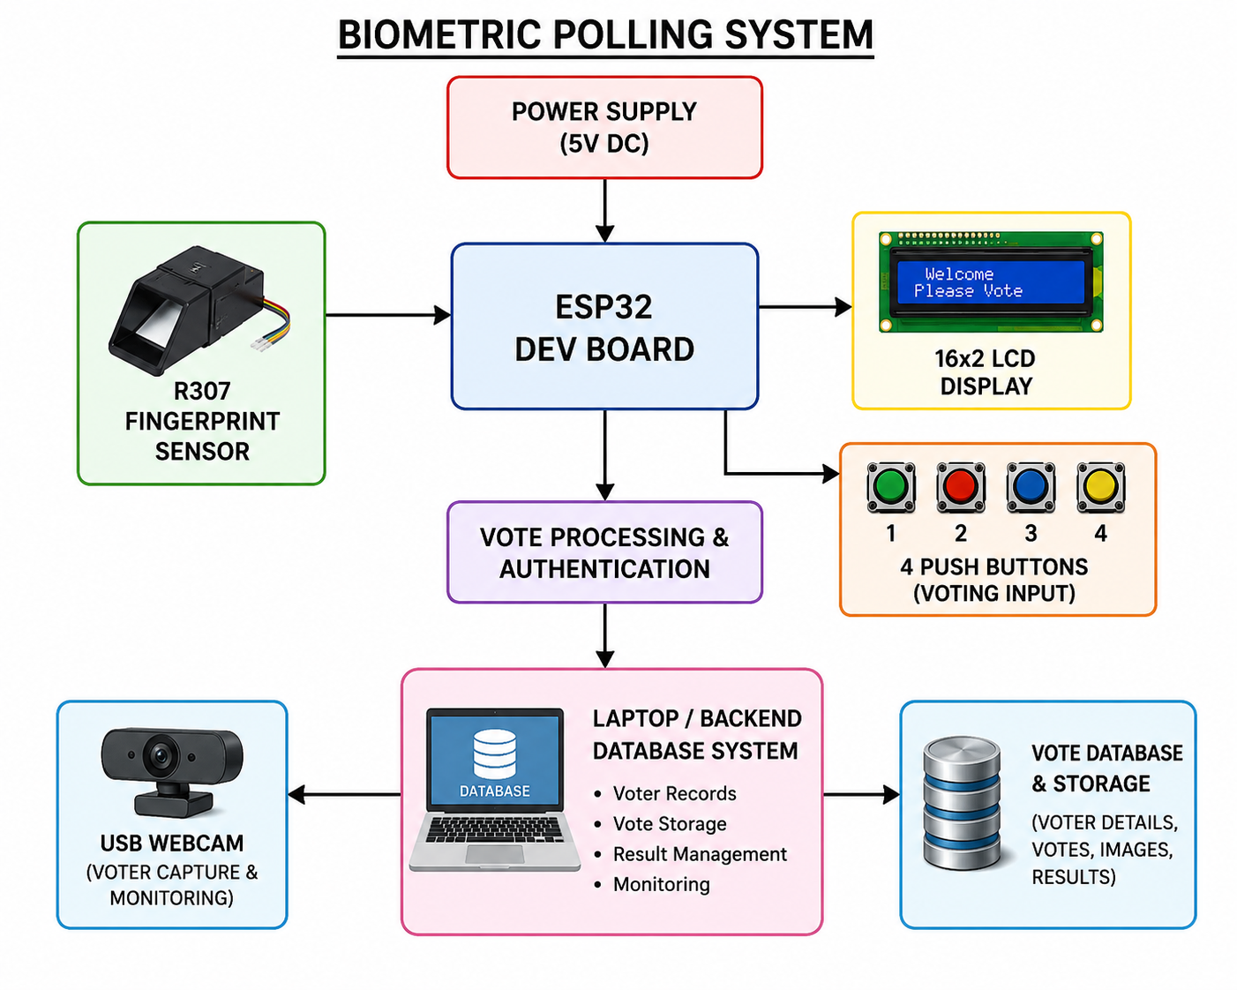
Figure3.1 Biometric polling System Block
The proposed work focuses on the design and implementation of a secure Biometric Polling System using the ESP32 microcontroller, R307 fingerprint sensor, push-button voting interface, LCD display module, webcam-based voter monitoring, and an offline Python-based database system. The objective of the system is to provide a reliable, low-cost, and transparent electronic voting platform capable of preventing fake voting, impersonation, and repeated voting attempts.
The system operates completely offline to avoid cybersecurity risks associated with cloud-based voting systems and internet connectivity. The ESP32 Dev Board acts as the central processing unit and controls all hardware and software operations including fingerprint verification, vote registration, LCD display management, push-button interfacing, and communication with the backend database system.
The R307 fingerprint sensor is used for biometric voter identification. During voter registration, fingerprints are enrolled and assigned unique template IDs. During voting, the voter places a finger on the sensor, and the fingerprint is compared with stored templates. If the fingerprint matches a registered voter, the system allows access to voting. If the voter has already voted, the system blocks further voting attempts and displays an appropriate message on the LCD screen.
A 16×2 I2C LCD display is integrated to provide real-time instructions and status messages such as “Place Finger,” “Verified,” “Select Candidate,” “Vote Recorded,” and “Already Voted.” Four push buttons connected to the ESP32 are used as voting inputs for different candidates. Once authentication is successful, the voter presses the desired candidate button to cast the vote.
A USB webcam connected to the backend laptop captures voter images during registration and voting. These images are stored in the offline database for monitoring and verification purposes. The backend database system is developed using Python and stores voter information, fingerprint IDs, vote counts, voter images, and voting status using CSV files and local storage.
An additional administrator protection mechanism is implemented using a rotating OTP-like dynamic access code. The ESP32 generates a continuously changing security code every 15 seconds using timer-based pseudo-random generation techniques. Only authorized administrators with the correct dynamic code can access the election results. This mechanism acts as an administrator access control system rather than a data encryption method.
The proposed system integrates embedded systems, biometric authentication, offline database management, serial communication, and monitoring technologies into a single secure voting platform. The system is suitable for applications such as college elections, employee voting systems, organizational polling, and small-scale booth-based voting environments.
3.1 Circuit Diagram

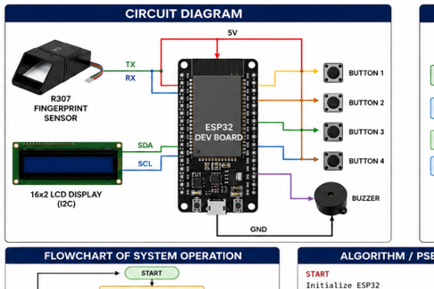
Figure 3.2 Circuit diagram
The proposed biometric polling system consists of the following hardware modules:
- ESP32 Dev Board
- R307 Fingerprint Sensor
- 16×2 LCD Display
- Four Push Buttons
- USB Webcam
- Laptop with Python Backend
- Offline Database Storage
- 5V DC Power Supply
The ESP32 acts as the central controller that manages fingerprint verification, vote processing, LCD communication, button input handling, and database communication.
3.2 Pin connection diagram
COMPONENTS | ESP32 PIN
R307 TX | GPIO16 (RX2)
R307 RX | GPIO17 (TX2)
LCD SDA | GPIO21
LCD SCL | GPIO22
Push Button 1 | GPIO13
Push Button 2 | GPIO12
Push Button 3 | GPIO14
Push Button 4 | GPIO27
Buzzer | GPIO26
VCC | 5V

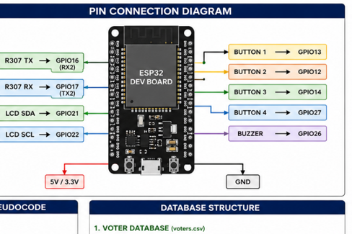
Figure 3.3 Pin Connection Diagram

Chapter 4
HARDWARE DESCRIPTION

4.1 ESP32 Dev Board
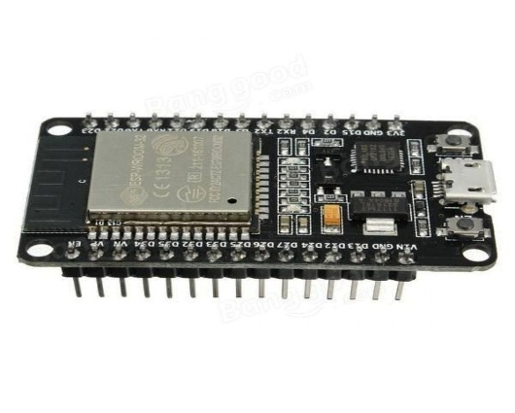
Figure 4.1 ESP 32 Dev Board
The ESP32 microcontroller serves as the central processing unit of the biometric polling system. It performs the following operations:
- Interfaces with fingerprint sensor
- Reads push button inputs
- Controls LCD display
- Communicates with laptop backend
- Processes vote data
The ESP32 is selected due to its:
- High processing speed
- Low power consumption
- Built-in Wi-Fi and Bluetooth support
- Multiple GPIO pins
- UART communication capability
Specifications of ESP32:
- Operating Voltage: 3.3V
- Input Voltage: 5V via USB
- Clock Frequency: 240 MHz
- Flash Memory: 4 MB
- Wi-Fi and Bluetooth support
- Dual-core processor
- Multiple UART, SPI, and I2C interfaces
4.2 R307 Fingerprint Sensor
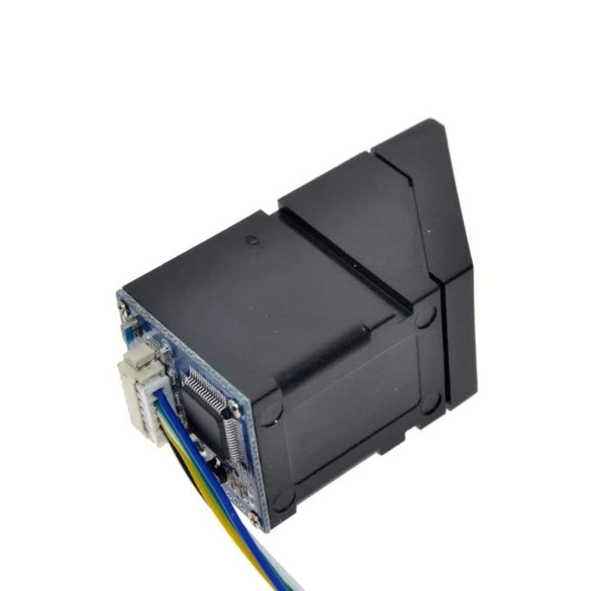
Figure 4.2 R307 Fingerprint Sensor
The R307 fingerprint sensor is used for voter authentication.
Functions:
- Fingerprint enrollment
- Fingerprint matching
- User identification
- Duplicate prevention
The sensor communicates with the ESP32 using UART serial communication.
Specifications of R307 Fingerprint Sensor:
- Operating Voltage: 3.3V–5V
- Communication Protocol: UART
- Baud Rate: 57600 bps
- Fingerprint Capacity: 1000 templates
- Matching Time: Less than 1 second
- High fingerprint matching accuracy
4.3 16×2 LCD Display
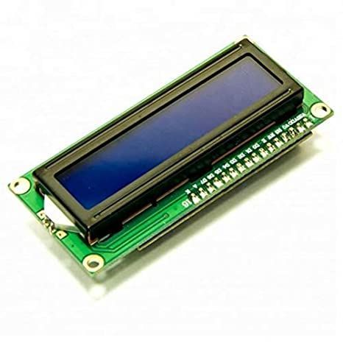
Figure 4.3 16x2 LCD Display
The LCD module displays:
- System status
- Authentication messages
- Voting instructions
- Vote confirmation
- Error messages
Example Messages:
- “Place Finger”
- “Access Granted”
- “Vote Recorded”
4.4 NSK193 Push Buttons

Figure 4.4 NSK193 Push Buttons
Four push buttons are used for voting.
Each button represents:
- Candidate 1
- Candidate 2
- Candidate 3
- Candidate 4
The buttons are connected to ESP32 GPIO pins.
4.5 USB Webcam
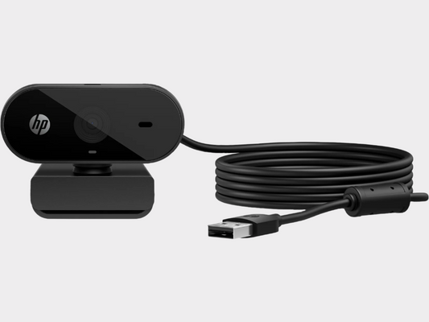
Figure 4.5 USB Webcam
The USB webcam is connected to the laptop for:
- Capturing voter images
- Monitoring polling activity
- Improving system transparency
- Maintaining voting records
Specifications of USB Webcam:
- Interface: USB 2.0
- Resolution: 720p/1080p
- Used for voter image capture and monitoring
4.6 Laptop Backend System
The laptop acts as the:
- Main database server
- Monitoring interface
- Vote counting system
- Webcam processing unit
The backend stores:
- Voter details
- Fingerprint IDs
- Captured images
- Vote counts
4.7 Hardware Design Advantages
- Secure authentication
- Compact design
- Real-time monitoring
- Easy scalability
- Low hardware complexity
4.8 Power Supply
- 4.x Power Supply Unit
The biometric polling system operates using a regulated 5V DC power supply. The ESP32 board receives power through a USB connection, while the fingerprint sensor and LCD module operate using 5V supply. Stable power supply is necessary for reliable authentication and voting operations.
4.9 UART Communication Section
- 4.x Serial Communication
UART serial communication is used between the ESP32 and R307 fingerprint sensor. GPIO16 and GPIO17 are configured as RX and TX pins respectively. The communication baud rate is set to 57600 bps for reliable data transmission.
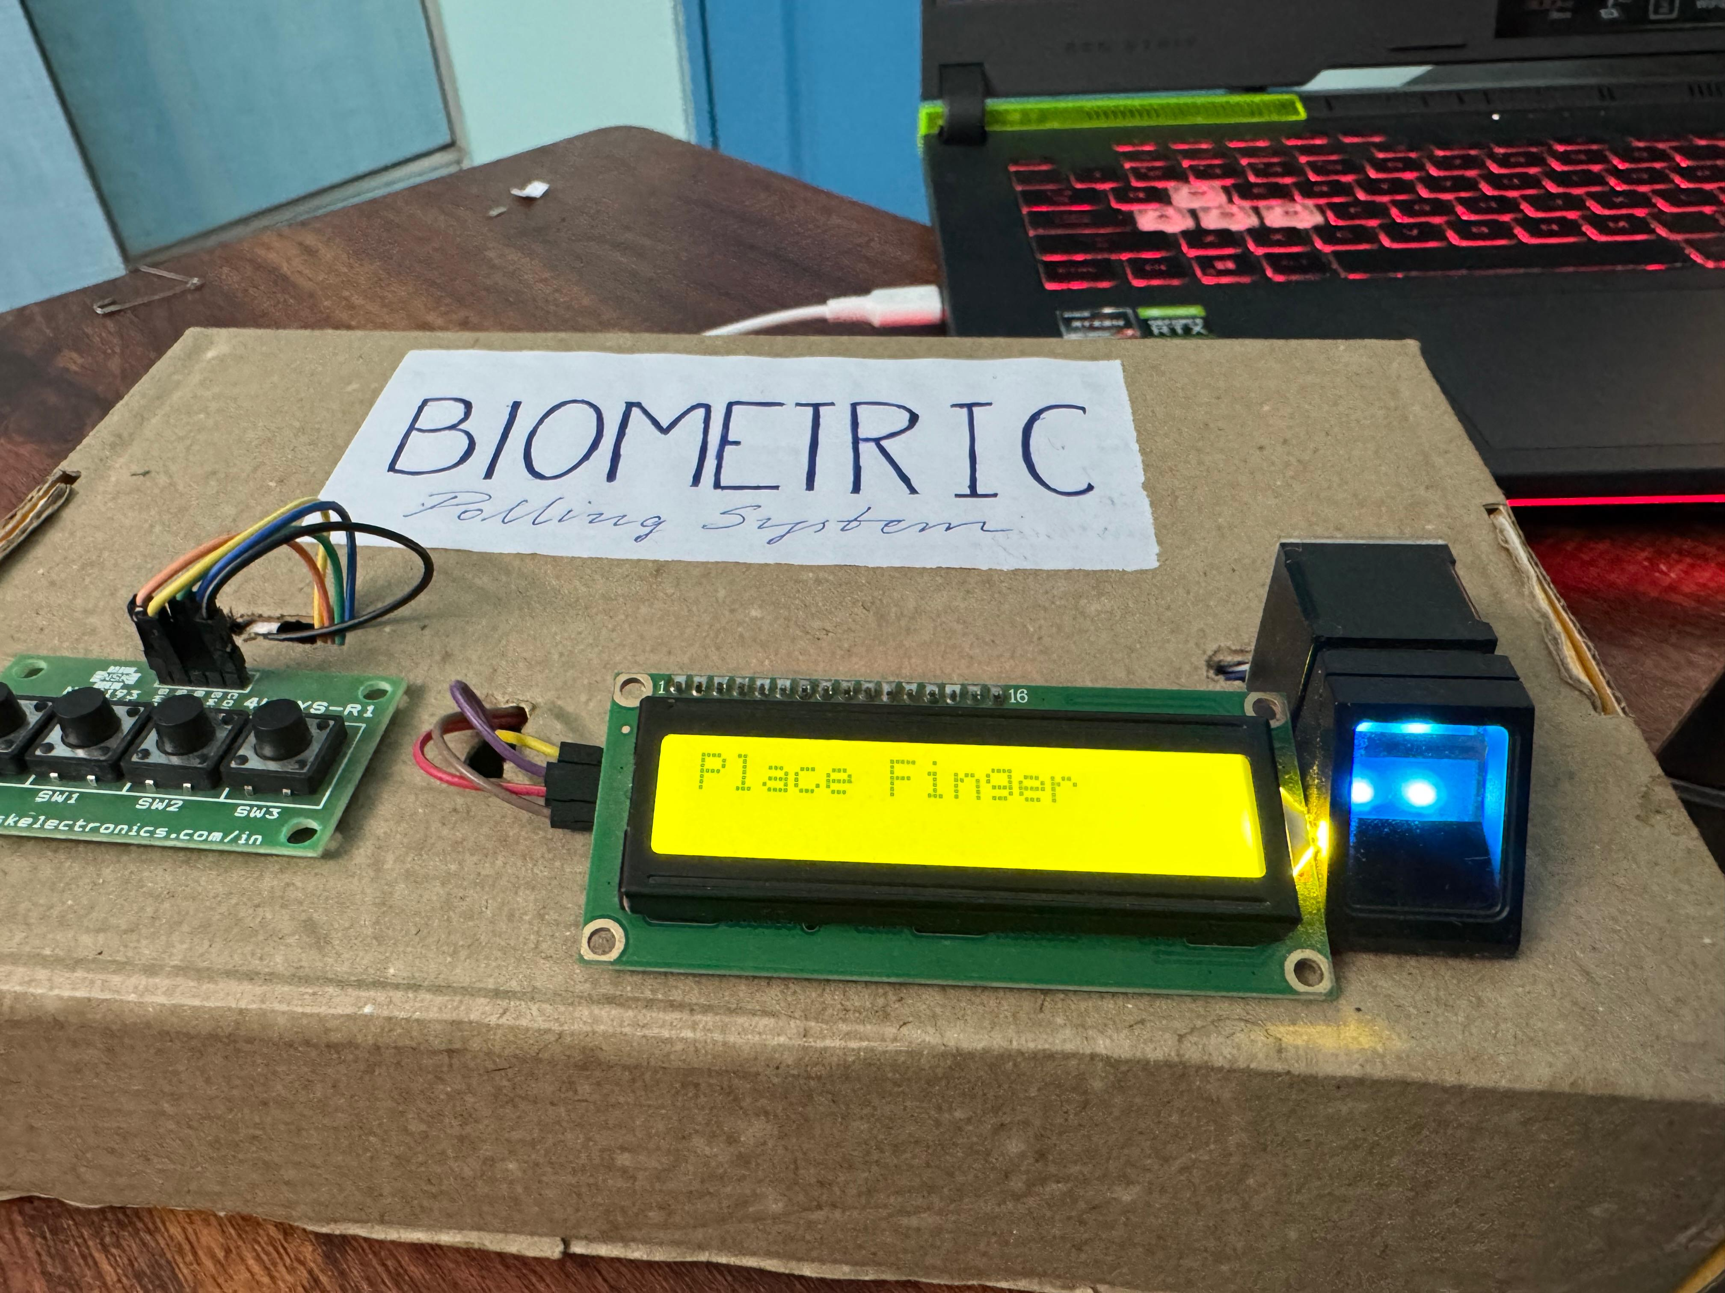
Figure 4.6 Hardware Setup
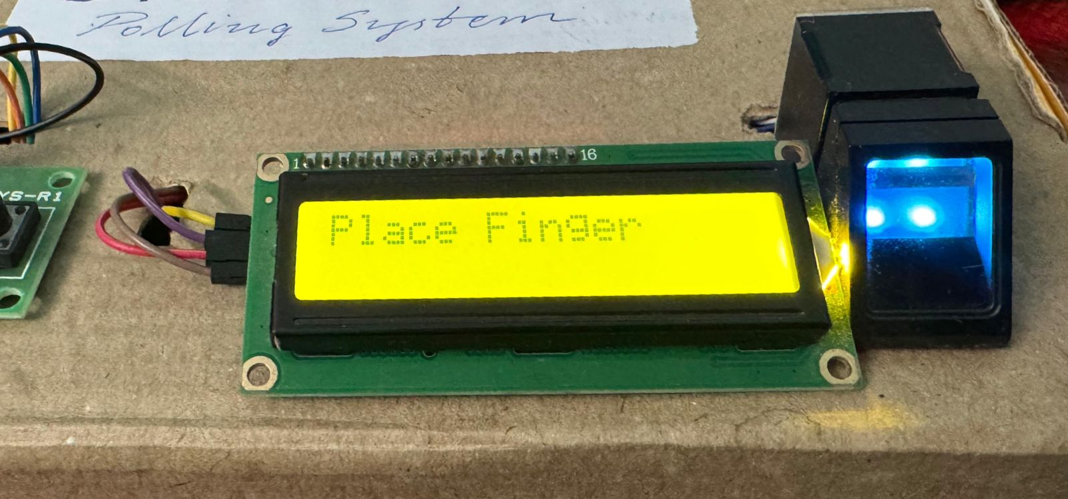
Figure 4.7 LCD display and fingerprint enrollment
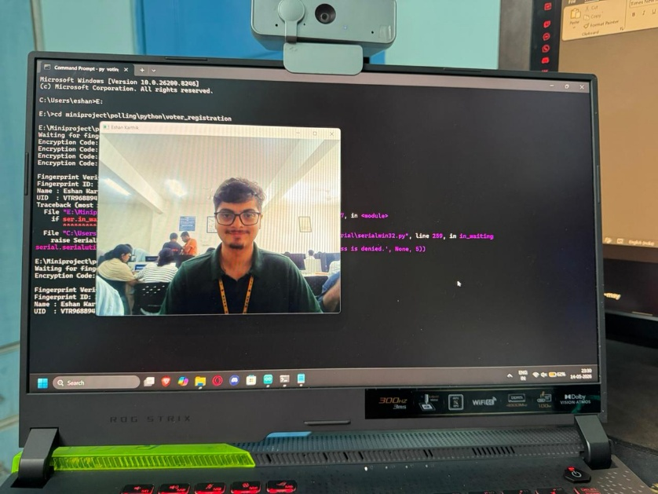
Figure 4.8 Voting process with verification and encryption

Chapter 5
SOFTWARE DESCRIPTION
The software for the biometric polling system is developed using Arduino IDE and backend database tools.
5.1 Software Tools Used
- Arduino IDE
- ESP32 Board Package
- Fingerprint Sensor Library
- LiquidCrystal Library
- Serial Communication Library
- Python Backend / Database Software
5.2 ESP32 Software Functions
Fingerprint Initialization
- Initializes R307 sensor
- Loads stored fingerprint templates
Authentication Logic
- Verifies voter fingerprints
- Prevents multiple voting attempts
Voting Control
- Reads push button inputs
- Registers selected vote
LCD Control
- Displays instructions and status
5.3 Backend Software Functions
The laptop backend performs:
- Database management
- Vote counting
- Webcam image storage
- Real-time monitoring
- Report generation
5.4 Software Workflow
Fingerprint Scan → Authentication → Webcam Capture → Vote Button Activation → Vote Registration → Database Update → LCD Confirmation
5.5 Software Advantages
- Fast response time
- Secure authentication process
- Reliable database storage
- Easy maintenance and upgrades
5.6 Algorithm
START
Initialize ESP32 and peripherals
Initialize LCD, fingerprint sensor, buttons, and database
WHILE system is active
Display "Place Finger"
Capture fingerprint
IF fingerprint matched THEN
Check voter status
IF voter already voted THEN
Display "Already Voted"
ELSE
Display "Select Candidate"
Wait for button press
Record selected vote
Update voter status to "Voted"
Capture voter image
Save vote and voter details in database
Display "Vote Recorded"
ENDIF
ELSE
Display "Access Denied"
ENDIF
ENDWHILE
STOP
5.7 Encryption and Security
The system uses password-protected result access and OTP-based verification for improved security. Future versions can implement AES encryption for secure database protection.
5.8 CSV Limitation
The system uses a CSV-based offline database for storing voter records and vote data. Although simple and cost-effective, CSV storage lacks built-in encryption, access control, transaction management, indexing, and recovery mechanisms. The database is vulnerable to unauthorized modification, data corruption during power failures, and reduced performance with large datasets. Therefore, the current implementation is suitable mainly for small-scale offline voting applications and may require secure database systems such as SQLite or MySQL for large-scale deployment.
Chapter 6
IMPLEMENTATION
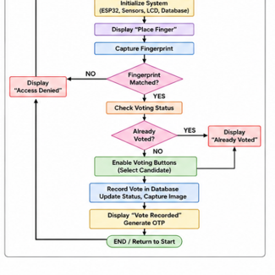
Figure 6.1 Flowchart of system operation

The implementation of the proposed Biometric Polling System combines embedded hardware, biometric identification, offline database management, and secure administrator access mechanisms into a single integrated voting platform. The system is developed using the ESP32 Dev Board, R307 fingerprint sensor, 16×2 I2C LCD display, push-button voting interface, buzzer module, USB webcam, and a Python-based offline database system.
The ESP32 microcontroller acts as the central controller responsible for fingerprint verification, LCD communication, vote registration, button handling, buzzer feedback, and serial communication with the backend database system. The system is programmed using Arduino IDE, while Python is used for database management and webcam image capture.
The R307 fingerprint sensor is connected to the ESP32 using UART serial communication through GPIO16 and GPIO17. During voter registration, fingerprints are enrolled and assigned unique template IDs. During voting, the sensor captures the fingerprint image and compares it with stored templates. If the fingerprint matches a registered voter, the system grants access to vote; otherwise, access is denied.
A 16×2 I2C LCD display connected through GPIO21 and GPIO22 provides instructions and status messages such as “Place Finger,” “Verified,” “Select Candidate,” “Vote Recorded,” and “Already Voted.” Four push buttons connected to GPIO13, GPIO12, GPIO14, and GPIO27 are used for candidate selection. After successful fingerprint verification, the voter presses the desired button to cast the vote.
The backend system uses Python and CSV-based local storage to maintain voter details, fingerprint IDs, voter images, vote counts, and voting status. A USB webcam connected to the laptop captures voter images during registration and voting for additional monitoring and verification. Since the entire system operates offline, it avoids internet-based cybersecurity threats.
The system also implements a rotating OTP-like administrator access mechanism. The ESP32 generates a dynamic access code every 15 seconds using pseudo-random number generation and timer-based logic. Only authorized administrators with the active code can access the final election results.
6.1 Flowchart of System Operation
- Start System
- Initialize ESP32 and peripherals
- Display “Place Finger” on LCD
- Scan fingerprint using R307 sensor
- Compare fingerprint with stored templates
- If fingerprint does not match:
  - Display “Access Denied”
  - Return to standby mode
- If fingerprint matches:
  - Check voter status in database
- If voter already voted:
  - Display “Already Voted”
  - Block voting access
- If voter has not voted:
  - Enable voting buttons
- Voter selects candidate using push button
- Record vote in database
- Update voter status as “Voted”
- Capture voter image using webcam
- Display “Vote Recorded”
- Generate dynamic access code
- Return to standby mode
6.2 Algorithm / Pseudocode for Voting Process
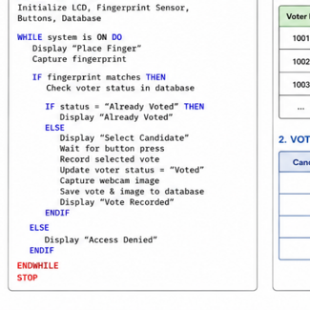
Figure 6.2 Algorithm
6.3 Database Structure Explanation
The proposed biometric polling system uses an offline Python-based database system implemented using CSV files and local storage. The database is divided into two major sections: the voter database and the vote database. The voter database stores important details such as voter ID, voter name, fingerprint template ID, webcam image path, and voting status. This information helps the system identify authorized voters and prevent repeated voting attempts.
The vote database maintains candidate details and vote counts. Each candidate is assigned a unique candidate ID and a corresponding vote counter. Whenever a voter successfully casts a vote, the database is updated immediately to maintain accuracy and consistency. Since the system operates completely offline, the risk of internet-based attacks and remote unauthorized access is significantly reduced.
6.4 OTP Generation Mechanism
The proposed biometric voting system implements a dynamic OTP-based encryption mechanism to secure encrypted voting data and encrypted vote count access. The system continuously generates a random 6-digit encryption OTP using pseudo-random number generation within the ESP32 microcontroller. This encryption OTP acts as a temporary encryption key for accessing encrypted vote counting data and is automatically regenerated every 15 seconds to enhance encrypted data security. Once a new encryption OTP is generated, the previous encryption OTP immediately becomes invalid, thereby preventing unauthorized access using expired encryption keys. The encrypted vote data can only be decrypted and accessed when the administrator enters the currently active encryption OTP correctly. If an incorrect or expired encryption OTP is entered, access to the encrypted voting data is denied. Since the complete encryption mechanism operates entirely offline without internet or cloud connectivity, the encrypted voting information remains locally protected from remote cyber threats. This dynamic encryption OTP generation mechanism significantly improves encrypted data confidentiality, encrypted result protection, and overall election security within the biometric voting system.
6.5 Encryption Method
The current implementation of the biometric polling system mainly relies on offline security mechanisms and controlled access rather than full cryptographic encryption. Security is achieved through biometric voter verification, restricted database access, dynamic administrator access codes, and local offline operation.
The fingerprint sensor ensures that only registered voters can cast votes, while the database maintains voting status records to prevent duplicate voting. The dynamic administrator access code further restricts unauthorized access to election results. Since the database is stored locally and disconnected from the internet, the risk of cyberattacks is minimized.
Future versions of the system can implement advanced encryption techniques such as AES encryption, RSA encryption, SHA hashing, and blockchain-based vote storage to further improve data confidentiality and security.
6.6 Testing Methodology
The biometric polling system was tested using both hardware and software validation methods to ensure reliable operation and accurate performance. Fingerprint verification testing was conducted by enrolling multiple users and checking the system response for both valid and invalid fingerprints. The matching accuracy and response time were carefully observed during testing.
Duplicate voting testing was performed by attempting multiple voting operations using the same fingerprint. The system successfully detected previously voted users and blocked repeated voting attempts. Push button testing was conducted to verify proper vote registration for each candidate button. LCD display testing ensured that all status messages were displayed correctly during every stage of operation.
Database testing was performed to confirm correct storage of voter records, vote counts, and voting status updates in CSV files. OTP access testing verified proper code generation, expiration timing, and administrator authentication functionality. Long-duration operation testing was also carried out to check the stability of communication between the ESP32 and connected peripherals.
The testing results confirmed that the proposed biometric polling system operates reliably and efficiently for secure offline electronic voting applications.
6.7 Performance Metrics
The performance of the biometric polling system was evaluated using parameters such as fingerprint matching accuracy, response time, vote registration delay, and database update speed. The R307 fingerprint sensor achieved an accuracy ranging from 95% to 98% under normal operating conditions. The average fingerprint verification time was observed to be between 1 and 2 seconds, while vote registration was completed in less than 1 second.
The LCD display responded within approximately 500 milliseconds, and the database update process required nearly 1 second. Duplicate voting detection achieved 100% success during testing, confirming reliable prevention of repeated voting attempts.
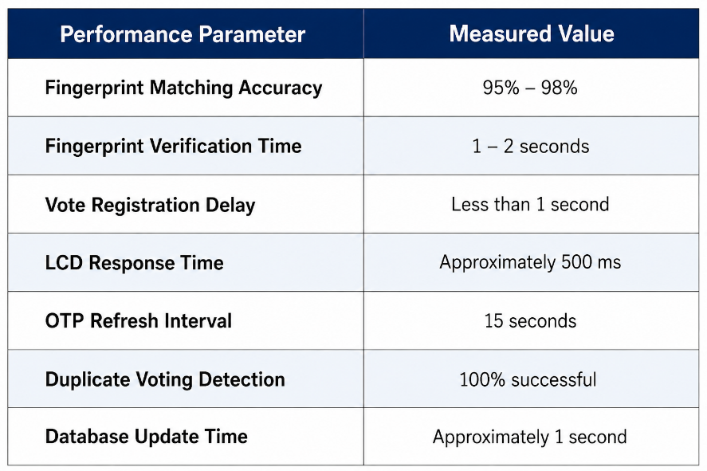
figure 6.3 performance metrics
6.8 Result tables
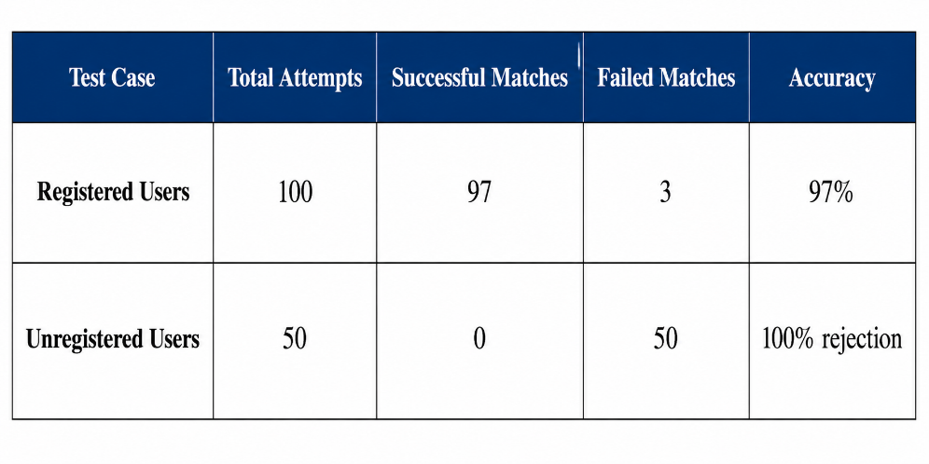
Figure 6.4 fingerprint authentication results

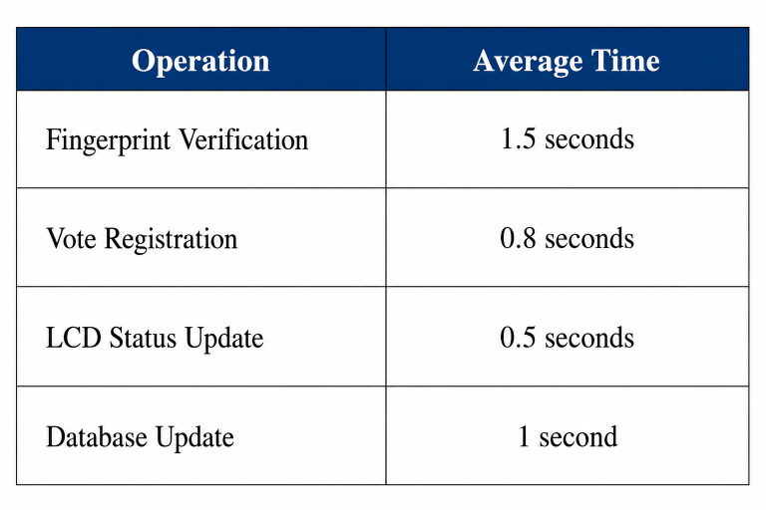
Figure 6.5 voting response performance

Chapter 7
RESULT & DISCUSSION
The proposed Biometric Polling System using ESP32, R307 fingerprint sensor, webcam-based voter verification, and offline secure database was successfully designed, implemented, and tested. The system effectively demonstrated secure biometric authentication, accurate vote recording, duplicate vote prevention, and protected result management. The integration of embedded hardware and Python-based backend software resulted in reliable and efficient system operation.
During testing, the R307 fingerprint sensor accurately identified registered voters by comparing scanned fingerprints with stored templates. The authentication process was fast and reliable, and only authorized users were allowed to proceed to the voting stage. Unregistered fingerprints were denied access, ensuring improved election security and prevention of impersonation.
The webcam-based image verification system successfully captured and displayed voter images stored during registration. This provided an additional layer of identity confirmation and improved transparency during voting operations. The 16×2 LCD display effectively guided users by showing messages such as “Place Finger,” “Verified,” “Vote Now,” “Vote Recorded,” and “Already Voted.”
The NSK193 push-button module accurately recorded votes for different candidates after successful fingerprint verification. Once a vote was cast, the system immediately updated the offline database and marked the voter as “Already Voted,” thereby preventing duplicate voting attempts. The buzzer provided audio feedback during authentication and successful vote registration.
The offline Python backend system successfully maintained voter details, fingerprint IDs, captured images, and vote counts using CSV database files. Communication between the ESP32 and Python backend through serial communication operated efficiently with minimal delay.
7.1 System Limitations
Although the proposed Biometric Polling System provides secure and reliable electronic voting functionality, the system has certain limitations that may affect its performance under specific conditions.
* The fingerprint authentication process depends on proper finger placement and sensor cleanliness. Dust, moisture, or incorrect finger positioning may reduce matching accuracy.
* The storage capacity of the R307 fingerprint sensor and the CSV-based database limits the number of voters that can be registered in the current implementation.
* Since the database is maintained locally in offline storage, accidental deletion, hardware failure, or software crashes may result in data loss if backup mechanisms are not implemented.
* CSV-based database storage does not provide advanced security features such as strong encryption, automated backup, or multi-user access control.
* Webcam-based voter monitoring depends on proper lighting conditions and camera quality for accurate image capture and verification.
* The current implementation does not include a dedicated battery backup system; therefore, power interruptions may temporarily affect voting operations.
* Advanced security mechanisms such as blockchain-based vote storage, AES encryption, and cloud-based synchronization are not included in the present version of the system.

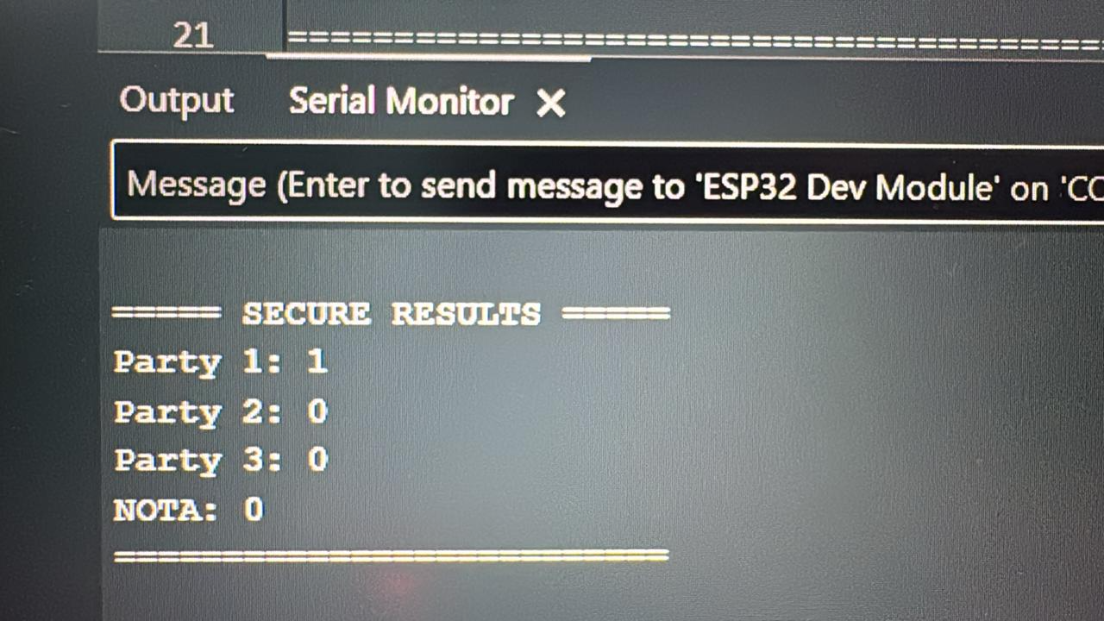
.Figure 7.1 Vote counting
Chapter 8
CONCLUSION & FUTURE SCOPE

The proposed biometric voting system successfully implements a secure offline electronic voting architecture using biometric authentication, embedded processing, and encrypted vote protection mechanisms. The system integrates an ESP32 Dev Module with an R307 Fingerprint Sensor for real-time fingerprint-based voter verification and duplicate vote prevention. The R307 module supports storage of approximately 1000 fingerprint templates and communicates with the ESP32 through UART serial communication operating at:

57600\ \text{bps}
While the Python-based encrypted database and monitoring interface communicates through USB serial communication at:

115200\ \text{bps}
The implemented dynamic OTP-based encryption mechanism continuously generates a new 6-digit encryption key every:

15\ \text{seconds}
Thereby improving encrypted vote count protection and reducing unauthorized encrypted data access risks. The system operates entirely offline using a regulated 5V DC supply with an average power requirement below:

1\ \text{A}
Which makes the architecture suitable for portable low-power election environments. The integration of biometric authentication, encrypted OTP-based data protection, offline encrypted database storage, webcam-assisted voter verification, and one-time voting enforcement collectively enhances encrypted election integrity, encrypted data confidentiality, and operational reliability. Overall, the developed system demonstrates a scalable, low-cost, and technically secure approach for modern biometric-based encrypted electronic voting applications.
CHAPTER 9
REFERENCES

[1] S. A. Karthik, R. Praveen, and M. Vignesh, “Fingerprint Based Electronic Voting Machine Using Microcontroller,” International Journal of Engineering Research & Technology (IJERT), vol. 9, no. 5, pp. 112–116, May 2020.

[2] A. Kumar and S. Singh, “Biometric Authentication System for Secure Electronic Voting,” International Journal of Computer Applications, vol. 176, no. 32, pp. 25–30, Apr. 2020.

[3] M. K. Hasan, M. M. Rahman, and S. Islam, “Design and Implementation of Fingerprint Based Voting System,” in Proc. IEEE International Conference on Electrical, Computer and Communication Engineering (ECCE), Cox’s Bazar, Bangladesh, 2019, pp. 1–5.

[4] R. Ramya and P. Deepalakshmi, “Secure Smart Voting System Using Biometrics,” International Journal of Advanced Research in Computer and Communication Engineering, vol. 8, no. 6, pp. 45–50, Jun. 2019.

[5] Espressif Systems, “ESP32 Series Datasheet,” Espressif Systems, Shanghai, China, Tech. Rep., 2023.

[6] Adafruit Industries, “I2C LCD Display Interfacing Guide,” Adafruit Learning System, New York, NY, USA, 2022.

[7] Grow Technology, “R307 Fingerprint Sensor User Manual,” Shenzhen Grow Technology Co., Ltd., Shenzhen, China, 2021.
[
.

BILL OF MATERIALS
Sl.No | Items | Rate (in Rs.) | Quantity | Amount
1 | ESP 32 | 350 | 2 | 700
2 | R307 Fingerprint Sensor | 650 | 1 | 650
3 | USB Webcam | 555 | 1 | 555
4 | LCD 16x2 Display | 200 | 1 | 200
5 | Jumper Wires | 2 | 50 | 100
 | Total |  |  | 2205

